Practical 01: Create a simple bar chart using student marks or sales data and explain what it shows.
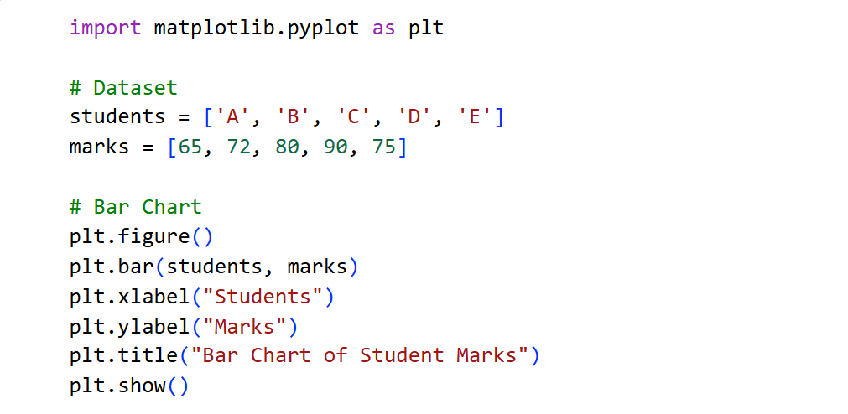
Code :-

Output : -
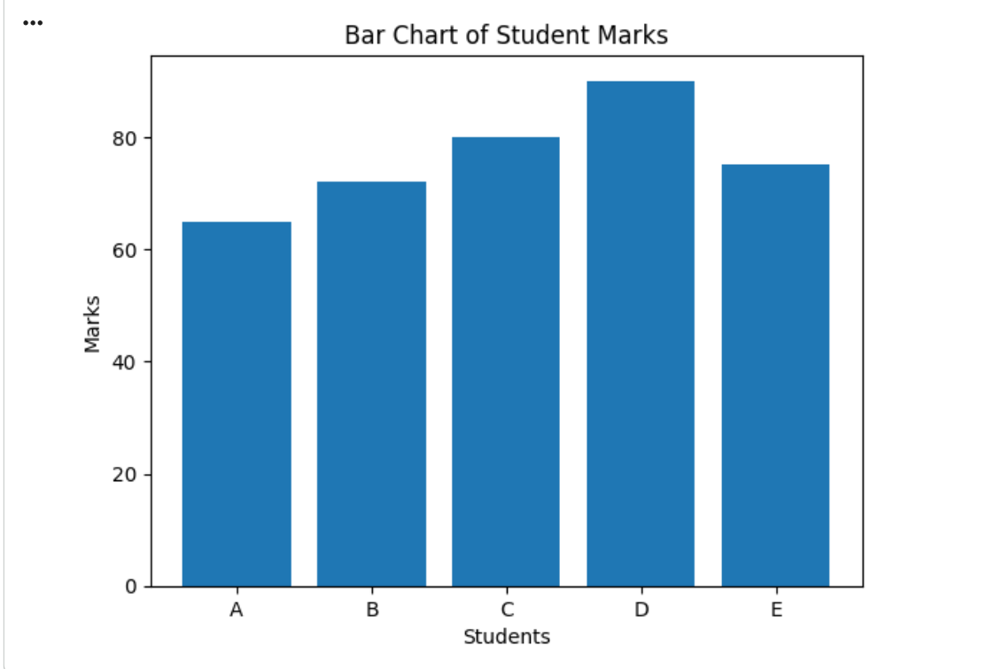

Practical 02: . Draw a line chart to represent time-based data (monthly attendance or sales).
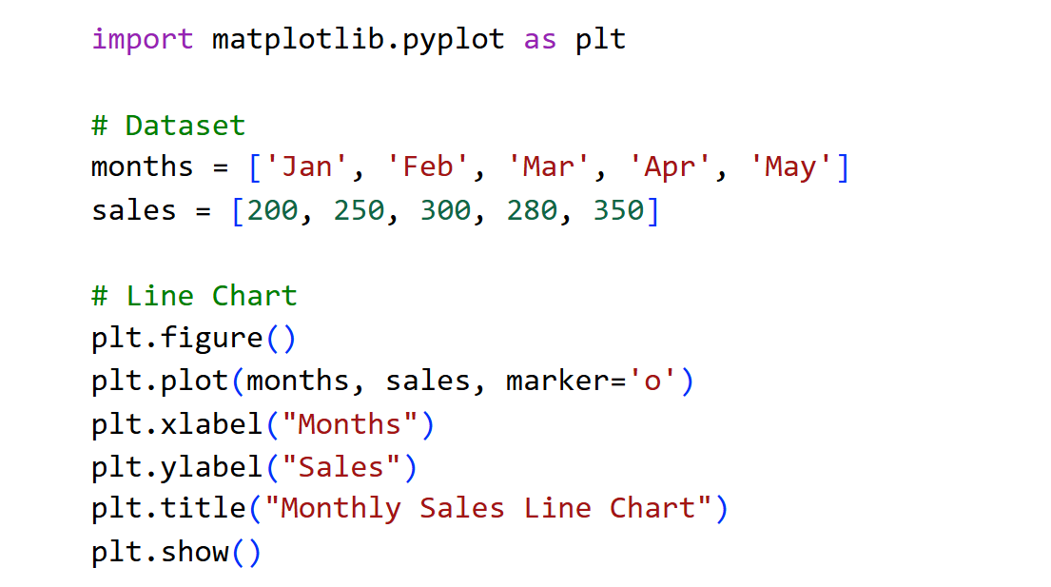
Code :-

Output :-
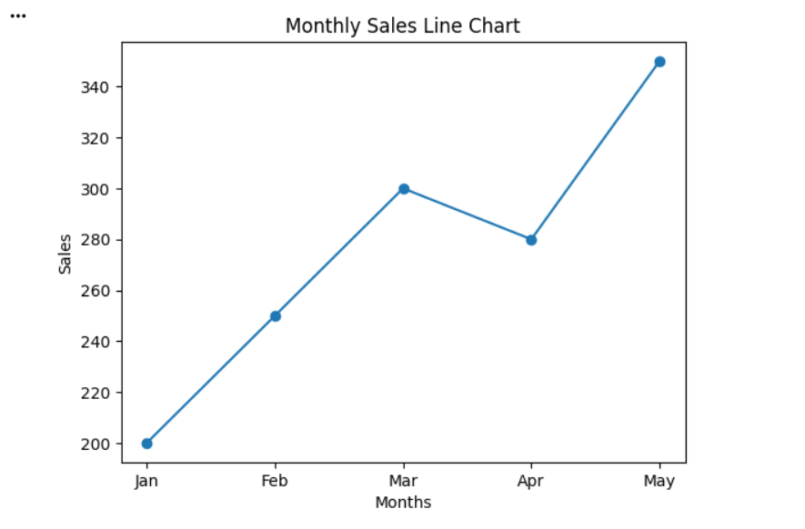

Practical 03: Perform data representation vs data presentation using at least two chart types.
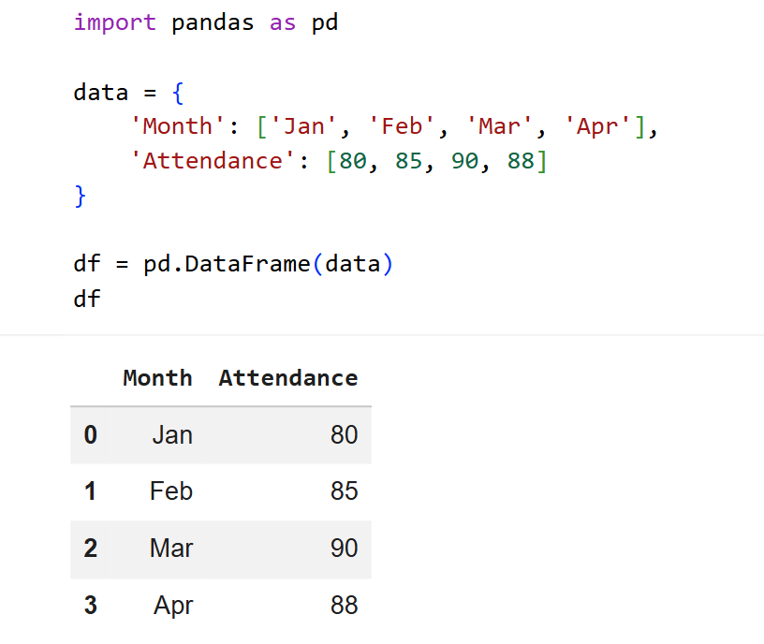
- Representation (Table)

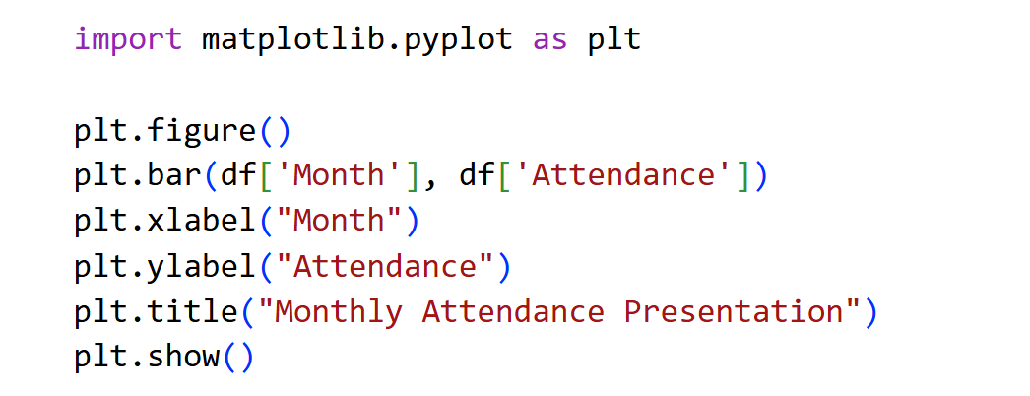
- Presentation (Bar Chart)

Output :-
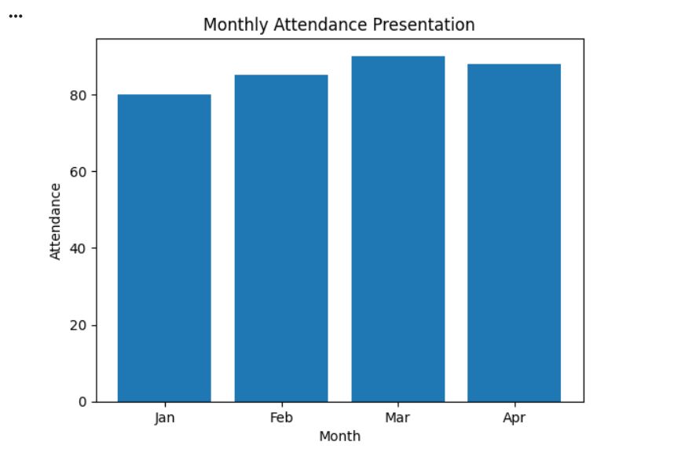

Practical 04: Identify the purpose of data visualization for a dataset and use a donut chart.
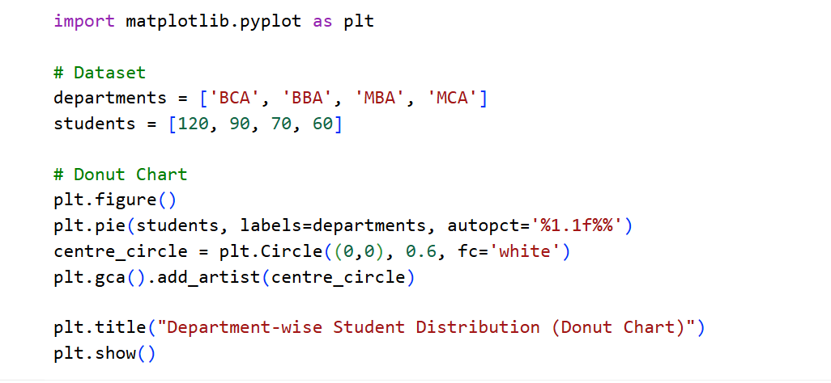
Code :-

Output :-
